**Dashboard Guide**

To access the dashboard, link or cut and paste the link below.

[D211_Task_1_Dashboard | Tableau Public](https://public.tableau.com/app/profile/julia.amanda.terzin/viz/D211_Task_1_Dashboard/Dashboard?publish=yes)

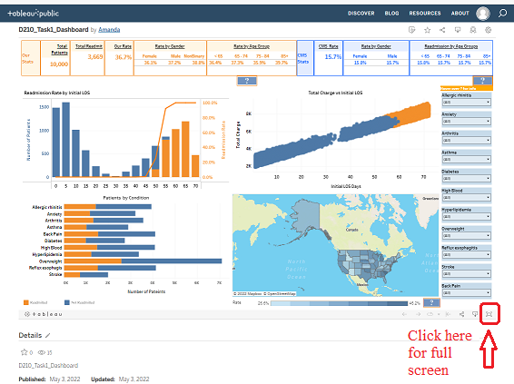

Press ESC to leave fullscreen.

**Dashboard Sections**

**Our Stats**

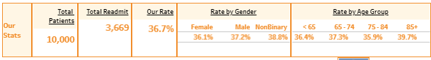

From our data set.

Numbers appear in orange.

Each will update according to the filters chosen.

1. Total Patients- total number of patients.
2. Total Readmit- the number of patients readmitted from the total.
3. Our Rate- readmission percentage.
4. Rate by Gender- percentage by gender.

-Clicking on gender will filter the dashboard by gender, re-click or press ESC to clear.

1. Rate by Age Group- percentage by age group.

-Clicking on an age group will filter the dashboard by age group, re-click or press ESC to clear.

**CMS Stats**

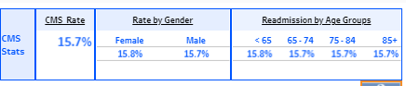

From the CMS data set.

Numbers appear in blue.

Each will update for the state filter.

1. CMS Rate- readmission percentage.
2. Rate by Gender- percentage by gender.
3. Rate by Age Group- percentage by age group.

**Readmission Rate by Initial LOS**

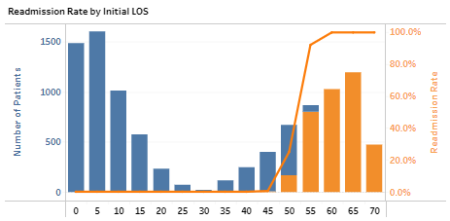

The bar graph shows the number of our patients by LOS in 5-day increments. Blue shade for not readmitted, orange for readmitted.

The line graph in orange shows the readmission rate as LOS increases.

Both graphs will change to reflect filter choices.

Clicking on a bar will filter the dashboard for the 5-day LOS increment. Clicking on the white space or pressing ESC will clear.

**Total Charge vs Initial LOS**

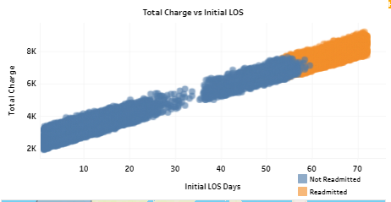

Scatter plot with total charge plotted against LOS color-coded with blue for not readmitted and orange for readmitted.

The graph will change to reflect filter choices.

**Patients by Condition**

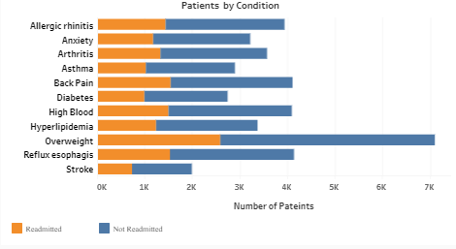

The bar graph shows the number of our patients by medical conditions. Blue shade for not readmitted, orange for readmitted.

The graph will change to reflect filter choices.

**Map**

A map of the 50 states, Washington DC, and Puerto Rico.

Shaded by readmission rate. The shade will change to reflect filter choices.

Hover over states to see state statistics and rank (example above).

Use + and - or scroll to zoom. Click and hold to pan around.

Click on a state to filter the dashboard by state. Press ESC or click over water to clear.

**Dropdown down medical condition filters**

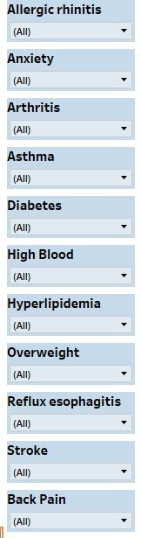 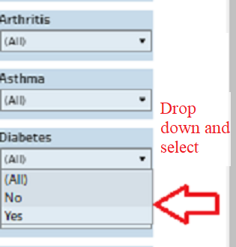 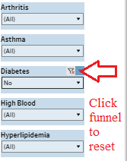

Dropdown filters for each of the eleven medical conditions with choices for yes, no, or all.

Filters dashboard for choices.

May select multiple conditions.

Click the funnel symbol or select All to clear.

**Instruction Boxes**

Hover over boxes for instructions.

